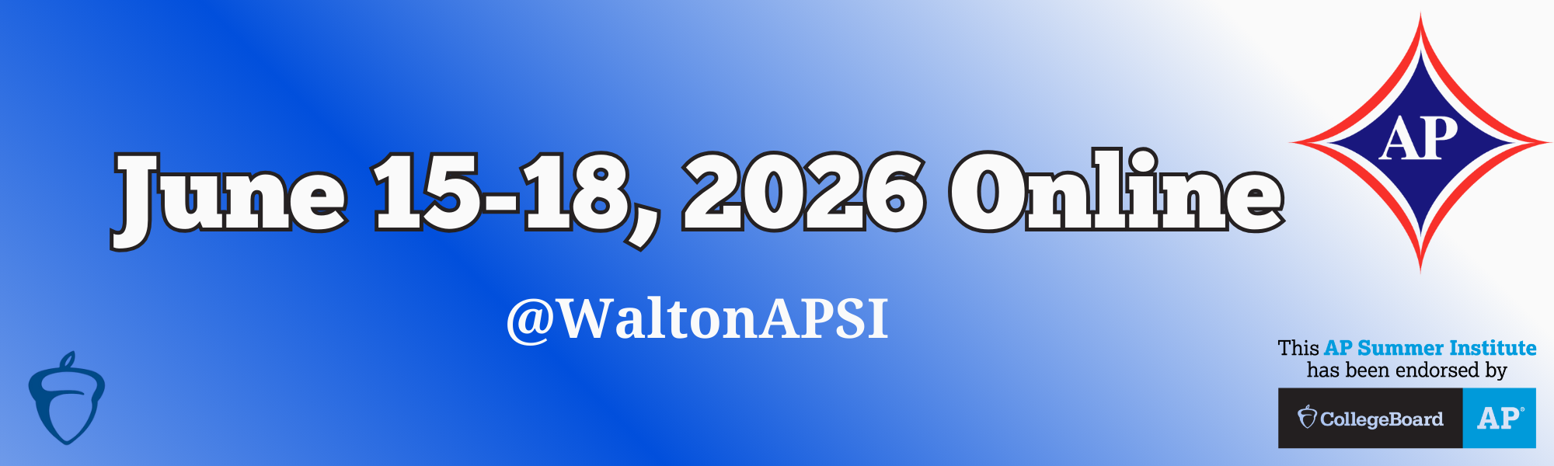

**Here are the AP® Sessions being offered during Week 1 June 15-18, 2026 Online.**

Click on the session for more **Information** about the session, the **Consultant** who will be leading the APSI session, **Tuition** and Payment Options, and the **Registration** information.

|  |
| --- |
| **AP African American Studies @WaltonAPSI Online Week 1** |
| **AP Art and Design @WaltonAPSI Online Week 1** |
| **AP Art History @WaltonAPSI Online Week 1** |
| **AP Biology @WaltonAPSI Online Week 1** |
| **AP Business with Personal Finance @WaltonAPSI Online Week 1** |
| **AP Business with Personal Finance @WaltonAPSI Online Week 1** |
| **AP Calculus AB @WaltonAPSI Online Week 1** |
| **AP Chemistry @WaltonAPSI Online Week 1** |
| **AP Chinese Language and Culture @WaltonAPSI Online Week 1** |
| **AP Computer Science A @WaltonAPSI Online Week 1** |
| **AP Computer Science Principles @WaltonAPSI Online Week 1** |
| **AP Cyber: Security @WaltonAPSI Online Week 1** |
| **AP Cyber: Networking @WaltonAPSI Online Week 1** |
| **AP Economics Macro and Micro (combined) @WaltonAPSI Online Week 1** |
| **AP English Language and Composition @WaltonAPSI Online Week 1** |
| **AP English Literature and Composition @WaltonAPSI Online Week 1** |
| **AP Environmental Science @WaltonAPSI Online Week 1** |
| **AP European History @WaltonAPSI Online Week 1** |
| **AP French Language and Culture @WaltonAPSI Online Week 1** |
| **AP Government and Politics Comparative @WaltonAPSI Online Week 1** |
| **AP Government and Politics U.S. @WaltonAPSI Online Week 1** |
| **AP Human Geography @WaltonAPSI Online Week 1** |
| **AP Music Theory @WaltonAPSI Online Week 1** |
| **AP Physics 1 - Experienced Teachers @WaltonAPSI Online Week 1** |
| **AP Physics 1 - New Teachers @WaltonAPSI Online Week 1** |
| **AP Physics 2 @WaltonAPSI Online Week 1** |
| **AP Physics C: Mechanics Experienced Teachers @WaltonAPSI Online Week 1** |
| **AP Physics C: Mechanics New Teachers @WaltonAPSI Online Week 1** |
| **AP Precalculus @WaltonAPSI Online Week 1 - # 1** |
| **AP Precalculus @WaltonAPSI Online Week 1 - # 2** |
| **AP Psychology - Experienced Teachers @WaltonAPSI Week 1** |
| **AP Psychology - New Teachers @WaltonAPSI Online Week 1** |
| **AP Spanish Language and Culture @WaltonAPSI Online Week 1 - #1** |
| **AP Spanish Language and Culture @WaltonAPSI Online Week 1 - #2** |
| **AP Spanish Literature and Culture APSI @WaltonAPSI Online Week 1** |
| **AP Statistics APSI @WaltonAPSI Online Week 1 - #1** |
| **AP Statistics APSI @WaltonAPSI Online Week 1 - #2** |
| **AP U.S. History APSI @WaltonAPSI Online Week 1** |
| **AP World History: Modern APSI @WaltonAPSI Online Week 1** |
| **AP Research @WaltonAPSI Online Week 1 - #1** |
| **AP Research @WaltonAPSI Online Week 1 - #2** |
| **AP Seminar @WaltonAPSI Online Week 1** |
| **AP Seminar for English Instructors (ELA) @WaltonAPSI Online Week 1 - #1** |
| **AP Seminar for English Instructors (ELA) @WaltonAPSI Online Week 1 - #2** |

**Questions?**

Email us at [**apsi@waltonapsi.org**](mailto:apsi@waltonapsi.org)or Call us at 1-770-833-8818